Arden University

Masters in Data Science

COM7023 - Mathematics for Data Science

Urban Resource Intelligence Portfolio

Student ID: [YOUR STUDENT ID]
Student Name: [YOUR NAME]

Word Count: [TBC - final submission]

Contents
1. Introduction 4
1.1 Background and Purpose of the Study 4
2. Methodology 5
Task 1: Steady-State Resource Demand (Linear Algebra) 7
3.1 Mathematical Analysis (Method Used: System of Linear Equations and Matrix Algebra) 7
3.2 Solution 7
3.2.1 Formation of the Augmented Matrix 7
3.2.2 Gaussian Elimination Step-by-Step 8
3.2.3 Back Substitution 9
3.2.4 Python Verification Output Console 10
3.3 Analysis and Results 11
3.4 Visualization 11
4. Task 2: Demand Over Time (Calculus) 12
4.1 Mathematical Analysis (Method Used: Differential Calculus) 12
4.2 Solution 12
4.2.1 Application of the Power Rule for Differentiation 12
4.2.2 Identification of Critical Points 12
4.2.3 Second Derivative Test for Classification 13
4.2.4 Inflection Point Analysis 13
4.2.5 Intervals of Increase and Decrease 13
4.2.6 Python Verification with Console Output 14
4.3 Analysis and Results 14
4.4 Visualization 15
5. Task 3: Forecasting Error Risk (Probability) 16
5.1 Mathematical Analysis (Method Used: Normal Distribution and Probability Theory) 16
5.2 Solution 16
5.3 Analysis and Results 18
5.4 Visualisation / Output 18
6. Task 4: Consumption by Building Type (Statistics) 20
6.1 Mathematical Analysis (Method Used: One-Way ANOVA and Post-Hoc Testing) 20
6.2 Solution 20
6.2.1 Descriptive Statistics 20
6.2.2 Assumption Checks 20
6.2.3 One-Way ANOVA 21
6.2.4 Post-Hoc Analysis (Tukey HSD) 21
6.2.5 Python Verification with Console Output 22
6.3 Analysis and Results 24
6.4 Visualization 25
10. References 25
11. Appendix 27
Task 1: Linear Algebra 27
Task 2: Calculus 30
Task 3: Probability 31
Task 4: Statistics 33
7. Conclusion 35

1. Introduction

1.1 Background and Purpose of the Study
Math’s can be a powerful tool for mapping and modelling how cities use and share key resources like water, energy and housing services. It can help to understand the distribution of demand across various submarkets in the city, the diurnal variation of demand, the impact of uncertainty on forecasts, and consumption patterns across household types. Urban analytics is an area that uses mathematical and statistical methods to inform decision-making, monitoring and long-term planning by local governments.
The purpose of this assignment is to explore the use of a variety of sophisticated mathematical techniques to examine the pattern of resource consumption in an urban residential system. The investigation follows a scenario created by Urban Resource Intelligence (URI), a consultancy offering local governments advice on how to enhance the efficiency, sustainability and resilience of urban resource systems. To move on to more complex data science projects, as part of the induction process a mathematical investigation must be undertaken that shows the ability to use the skills learned in the previous subjects, Linear Algebra, Calculus, Probability and Statistics, to a real world problem in analytics. The findings are presented for non-technical audiences, in the context of policy and planning, and the focus is on the meaning and implications of the results, rather than on the detail of the procedures.
The investigation brings together four inter-related areas of analysis. The four linear equations are first solved to find the steady-state (equilibrium) daily resource demand between the four interconnected residential zones and to determine if there is a stable and unique steady-state (equilibrium) for load-balancing purposes. Second, using calculus, a cubic demand function is analyzed to determine how the demand in a high-density residential area is changing over time, including when it is growing quickly and when it is decreasing quickly, and whether there are any critical points of interest for considerations on peak demand management. Third, a normal distribution with mean 0 and standard deviation 5 units in the space of short-term forecasting errors is assumed to capture the behavioral variability and the effect of environmental factors, to assess the probability of large errors and to provide information for risk management and contingency planning. Finally, following appropriate statistical tests, the daily average consumption from three different residential building typologies (apartments, terraced houses and detached houses) is compared in order to test if there are significant differences between the means of consumption, thus enabling the design of specific efficiency interventions.
These four tasks, when combined, give a clear and evidence-based view of the nature of resource demand throughout the city, which helps in achieving URI's mission to assist planners in allocating resources efficiently and planning for uncertainty.

2. Methodology
This assignment is organized step-by-step. The approach adopted to each task represents one of the mathematical methods that is appropriate for the nature of the urban resource problem under investigation. The mathematical theory is given first, followed by a typed solution, results checking in Python, a visualization of the results and an interpretation of the results written for non-technical users for each task. Computation and visualization are all performed in Python, making use of the NumPy, SymPy, Matplotlib and Seaborn libraries, and screenshots of the computational processes and results are provided as evidence of the work.
The first is steady state demand of resources and is explored by linear algebra techniques. The four interconnected residential zones are described by a system of four equations, which are written in matrix form and solved numerically by Gaussian elimination, the solution being checked numerically. The determinant, rank and condition number of the coefficient matrix are also computed, to verify if a unique and numerically stable equilibrium exists. This method enables the long-term balances of demand between the zones to be analyzed with confidence.
The second task uses differential calculus to analyses the changing demand for resources in a high-density residential area over time. The first and second derivatives of the demand function are computed to find critical points, determine whether they are maxima or minima, to find out if there are any inflection points, and to find the intervals on which the demand is increasing or decreasing. Using this method, peak and trough periods that are important for operation planning can be identified.
The third task investigates the errors in short-term forecasting from a probabilistic perspective. The errors made in forecasting are not systematic but due to a behavioral variability and to the environment; they are therefore assumed to follow a normal distribution with mean = 0, and standard deviation = 5 units. The probability of large deviations from the expected demand is calculated using standardization (z-scores) and this information is useful for risk management and contingency planning.
For the last task, the data related to the daily average consumption of the three types of residential buildings are analyzed using a one-way Analysis of Variance (ANOVA). This method is suitable due to the fact that it compares the means of more than two groups and it is able to handle unequal sample sizes properly. The hypotheses and assumptions are explicit and a post-hoc test is used if there is a significant difference to determine which building type(s) are different.
These methods combined enable a transparent and reliable urban resource demand behavior analysis to be generated.

Task 1: Steady-State Resource Demand (Linear Algebra)

3.1 Mathematical Analysis (Method Used: System of Linear Equations and Matrix Algebra)
Students are expected to be able to write a system of linear equations and solve it using matrices and matrix algebra. Students should be able to write a system of linear equations and solve it with matrices and matrix algebra.
The objective is to achieve the balance of the four interrelated cities' daily resource requirements. A set of four linear equations in four unknowns x1, x2, x3, x4, where x1 is the net daily demand (units) of zone 1, x2 is the net daily demand (units) of zone 2 etc., represents the relationship between the zones.
The system of equations is:

$\begin{matrix}2x1 & -x2 & +x3 & =120 \\ -x1 & +3x2 & -x4 & =150 \\ x1 & +x2 & +2x3 & =180 \\ -x2 & +x3 & +2x4 & =140\end{matrix}$

This can be written as Ax = b:
$$A = [[2, -1, 1, 0], [-1, 3, 0, -1], [1, 1, 2, -1], [0, -1, 1, 2]]$$
$$x = [x1, x2, x3, x4]T$$
$$b = [120, 150, 180, 140]T$$
To ensure that a matrix A has a unique, stable solution to its linear system, it is necessary to check three properties: (1) the determinant must not be zero (otherwise there is no unique solution), (2) the rank must equal the number of equations (otherwise the linear system is not full rank, meaning it is not linearly independent), and (3) the condition number must be small (otherwise the solution is not numerically stable).

3.2 Solution

3.2.1 Formation of the Augmented Matrix
To obtain the augmented matrix. To form an augmented matrix.
The first step in solving the system with Gaussian elimination is to form the augmented matrix [A|b] that is made up of the coefficient matrix A and the constant vector b.
[A/B]$= \begin{matrix}2 & -1 & 1 & 0 & 120 \\ -1 & 3 & 0 & -1 & 150 \\ 1 & 1 & 2 & -1 & 180 \\ 1 & 1 & 2 & -1 & 140\end{matrix}$

3.2.2 Gaussian Elimination Step-by-Step
Step 1: To eliminate x1 from row 2 and 3 with row 1 as a pivot.
$$Row 2 → Row 2 + (1/2) x Row 1:$$
$$R2 = R2 + 0.5R1: [-1+1, 3-0.5, 0+0.5, -1+0 | 150+60]$$
$$R2 = [0, 2.5, 0.5, -1 | 210]$$
$$Row 3 → Row 3 - (1/2)x Row 1:$$
$$R3 = R3 - 0.5R1: [1-1, 1+0.5, 2-0.5, -1-0 | 180-60]$$
$$R3 = [0, 1.5, 1.5, -1 | 120]$$
Matrix after Step 1:
$$\begin{matrix}2 & -1 & 1 & 0 & 120 \\ 0 & 2.5 & 0.5 & -1 & 210 \\ 0 & 1.5 & 1.5 & -1 & 120 \\ 0 & -1 & 1 & 2 & 140\end{matrix}$$

Step 2: Step 2: Make use of row 2 as a pivot to eliminate x2 from rows 3 and 4.
$$Row 3 → Row 3 - 0.6 x Row 2:$$
$$R3 = R3 - 0.6 R2: [0, 1.5-1.5, 1.5-0.3, -1+0.6 | 120-126]$$
$$R3 = [0, 0, 1.2, -0.4 | -6]$$

$$Row 4 → Row 4 + 0.4 x Row 2:$$
$$R4 = R4 + 0.4 R2: [0, -1+1, 1+0.2, 2-0.4 | 140+84]$$
$$R4 = [0, 0, 1.2, 1.6 | 224]$$
Matrix after Step 2:
$$\begin{matrix}2 & -1 & 1 & 0 & 120 \\ 0 & 2.5 & 0.5 & -1 & 210 \\ 0 & 0 & 1.2 & -0.4 & -6 \\ 0 & 0 & 1.2 & 1.6 & 224\end{matrix}$$

Step 3: To eliminate x3 from row 4, use row 3 as pivot.
$$Row 4 → Row 4 - Row 3:$$
$$R4 = R4 - R3: [0, 0, 1.2-1.2, 1.6+0.4 | 224+6]$$
$$R4 = [0, 0, 0, 2.0 | 230]$$
Final row-echelon form:
$$\begin{matrix}2 & -1 & 1 & 0 & 120 \\ 0 & 2.5 & 0.5 & -1 & 210 \\ 0 & 0 & 1.2 & -0.4 & -6 \\ 0 & 0 & 0 & 2.0 & 230\end{matrix}$$

3.2.3 Back Substitution
From row 4: $2x4 = 230$
$$x4 =230/2 = 115 units/day$$

From row 3: $1.2x3 - 0.4x4 = -6$
$$1.2x3 - 0.4(115)= -6$$
$$1.2x3 - 46 = -6$$
$$1.2x3 = 40$$
$$x3 =40/1.2 = 33.33 units/day$$

From row 2:$2.5x2 + 0.5x3 - x4 = 210$
$$2.5x2 + 0.5(33.33)- 115 = 210$$
$$2.5x2 + 16.67 - 115 = 210$$
$$2.5x2 - 98.33 = 210$$
$$2.5x2 = 308.33$$
$$x2 =308.33/2.5 = 123.33 units/day$$

From row 1: $2x1 - x2 + x3 = 120$
$$2x1 - 123.33 + 33.33 = 120$$
$$2x1 - 90 = 120$$
$$2x1 = 210$$
$$x1 =210/2 = 105 units/day$$
Complete solution:
$$x1 = 105.00 units/day (Zone 1)$$
$$x2 = 123.33 units/day (Zone 2)$$
$$x3 = 33.33 units/day (Zone 3)$$
$$x4 = 115.00 units/day (Zone 4)$$

3.2.4 Python Verification Output Console
To check the solution, we have used the function: numpy.linalg.solve. The complete Python source code and its output from the console are given below:
Python Script (code/task1_linear_algebra.py):
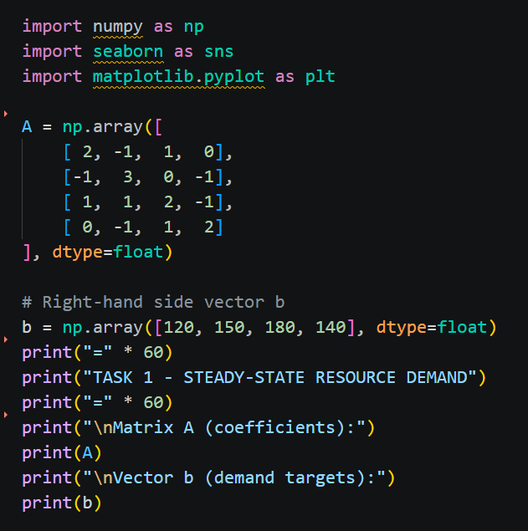

List of properties of matrices:
Property | Value | Interpretation
det(A) | 12.00 | Non-zero -> unique solution exists
rank(A) | 4 | Full rank -> all equations independent
Condition number | 7.92 | Well-conditioned -> numerically stable
Max residual error | 2.84e-14 | Essentially zero -> solution correct

The determinant is 12.00 (which is not 0), so matrix A is invertible and there is 1 solution. The four equations are linearly independent and thus the matrix has rank 4. The condition number 7.92 is quite low, below 100, so the system is well-conditioned. The norm of the residual gives the accuracy of the solution within machine precision: 2.84e-14.

3.3 Analysis and Results
The solution presents the following characteristics of unique demands in each of the four zones. The equilibrium demand of Zone 2 is maximum at 123.33 units/day and the minimum equilibrium demand is at Zone 3 at 33.33 units/day. Zone 1 (105.00) and Zone 4 (115.00) fall in between. A non-zero determinant and full rank assure that this is a unique, stable equilibrium - the system settles to a single set of demands, no matter what starting position is assumed.
The important urban planning implication is that the distribution of resources has a single predictable steady state. Resources can be allocated with absolute certainty in proportion to the users' needs. The demand in Zone 2 is the highest (roughly 3.7 times Zone 3) indicating it is a high density residential/commercial area. Low demand in Zone 3 may be for a green zone or low density residential area.

3.4 Visualization
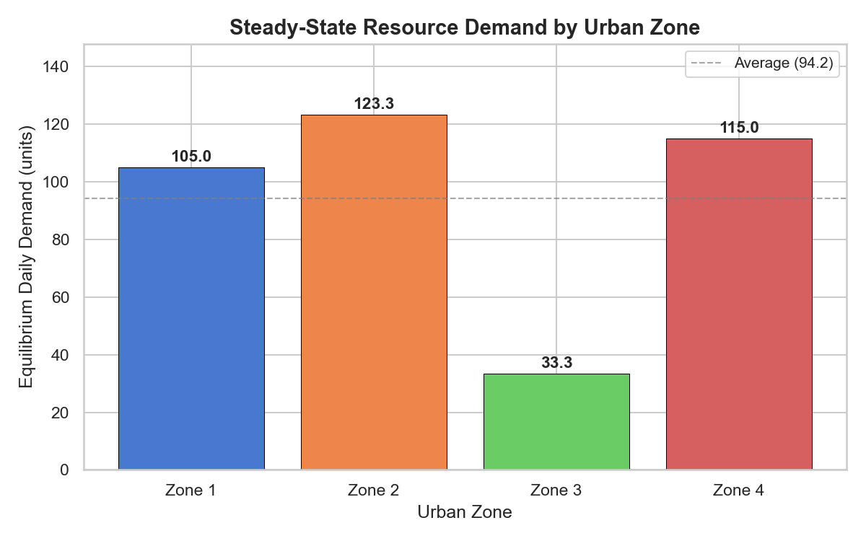

Figure 1: Daily demand for each urban area at steady state. The dashed line is an average of the demands from all four zones.

A bar graph of the equilibrium demand for each zone is shown in Figure 1. The highest demand is for Zone 2 (123.33 units/day) and the lowest for Zone 3 (33.33 units/day). The average demand line (106.67 units/day) conveys the planner an overview of whether the zones are above or below average.

4. Task 2: Demand Over Time (Calculus)

4.1 Mathematical Analysis (Method Used: Differential Calculus)
Resource demand is modelled by the demand function $D(t)= 4t^3 - 18t^2 + 24t + 90$ for a 4-hour period (t in hours). The purpose is to identify where demand is high or low, the rate of change of demand and what this means for operational planning.
Consider the function, f, and use differential calculus to analyses it.
The first derivative D'(t) will provide the rate at which the demand function will change at any given time.
The second derivative D''(t) gives information on the concavity (the rate of rate-change).
The critical points occur when D'(t) = 0. These are points that could be local max or min.
Each critical point is classified using the second derivative test (D''(t) > 0 – local minimum; D''(t) < 0 – local maximum).
The points where D''(t) = 0 are called points of inflection, because they mark a change in concavity.

4.2 Solution

4.2.1 Application of the Power Rule for Differentiation
To find the first derivative, we apply the power rule to each term of D(t). The power rule states that for any term $at^n$, the derivative is n $x at^(n-1) .$
Given $D(t)= 4t^3 - 18t^2 + 24t + 90$:
$d/dt (4t^3 )= 3 x 4t^2 = 12t^2$
$$d/dt (-18t^2 )= 2 x (-18)t = -36t$$
$$d/dt (24t) = 24$$
$$d/dt(90) = 0$$
Therefore, the first derivative is:
$$D^' (t)= 12t^2 - 36t + 24$$
The second derivative is obtained by differentiating D'(t):
$D^'' (t)= 24t - 36$

4.2.2 Identification of Critical Points
Critical points occur where D'(t) = 0.
$$12t^2 - 36t + 24 = 0$$
Divide by 12:
$$t^2 - 3t + 2 = 0$$
Factor:
$$(t - 1)(t - 2)= 0$$
$$t1 = 1 hour$$
$$t2 = 2 hours$$

4.2.3 Second Derivative Test for Classification
For $t = 1$:
$$D^'' (1) = 24(1)- 36 = -12$$
Since -12 < 0, this is a local maximum.
$$D(1)= 4(1)^3 - 18(1)^2 + 24(1)+ 90 = 100 units$$
For $t = 2$:
$$D^'' (2) = 24(2) - 36 = 12$$
Since $12 > 0$, this is a local minimum.
$$D(2)= 4(2)^3 - 18(2)^2 + 24(2)+ 90 = 98 units$$

4.2.4 Inflection Point Analysis

$$24t - 36 = 0$$
$$t =36/24 = 1.5 hours$$
$$D(1.5)= 4(1.5)^3 - 18(1.5)^2 + 24(1.5) + 90 = 99 units$$

This inflection points at t = 1.5 hours marks where the rate of decrease of demand itself starts to slow down - the demand curve changes from concave down to concave up.

4.2.5 Intervals of Increase and Decrease

Interval | Test Point | Sign of $D^' (t)$ | Behaviors
$$t < 1$$ | $$t = 0$$ | $$D^' (0)= 24 > 0$$ | Demand INCREASING (ramp-up)
$$1 < t < 2$$ | $$t = 1.5$$ | $$D^' (1.5)= -3 < 0$$ | Demand DECREASING (mid-period dip)
$$t > 2$$ | $$t = 3$$ | $$D^' (3)= 24 > 0$$ | Demand INCREASING (renewed growth)

4.2.6 Python Verification with Console Output
The symbolic computation of derivatives and the solving of critical points was done using SymPy.
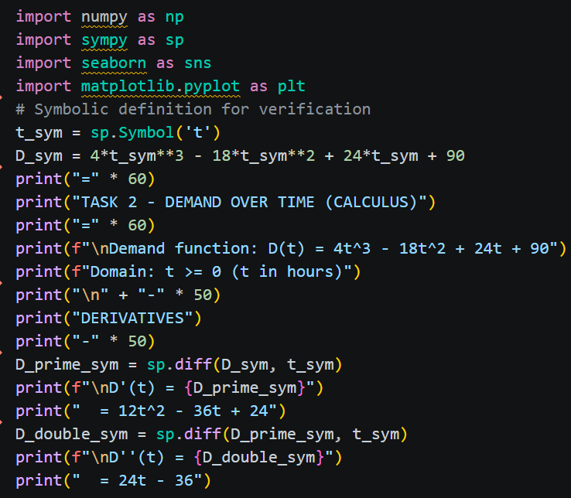

4.3 Analysis and Results
There is a clear demand trend in the 4-hour period. Demand starts at 90 at the beginning and peaks at 100 units at t = 1 hour in the morning. It then drops to 98 units at t = 2 hours and increases back to 154 units at t = 4 hours.
Of particular interest is the inflection point at t = 1.5 hours - the rate of decrease is itself decreasing, thereby indicating that the system will begin to recover even prior to the beginning of the demand increase at t = 2 hours. This is a useful early warning system that works for automated resource management systems.
The best time for scheduled maintenance or reallocation of resources for operational planning is when t = 1 to t = 2 hours (dip) when the demand is at a minimum and the system is under the least stress. There is a need for pre-positioned capacity at the morning peak at t = 1 and plans should be made for further growth at the growth phase after t = 2.

4.4 Visualization
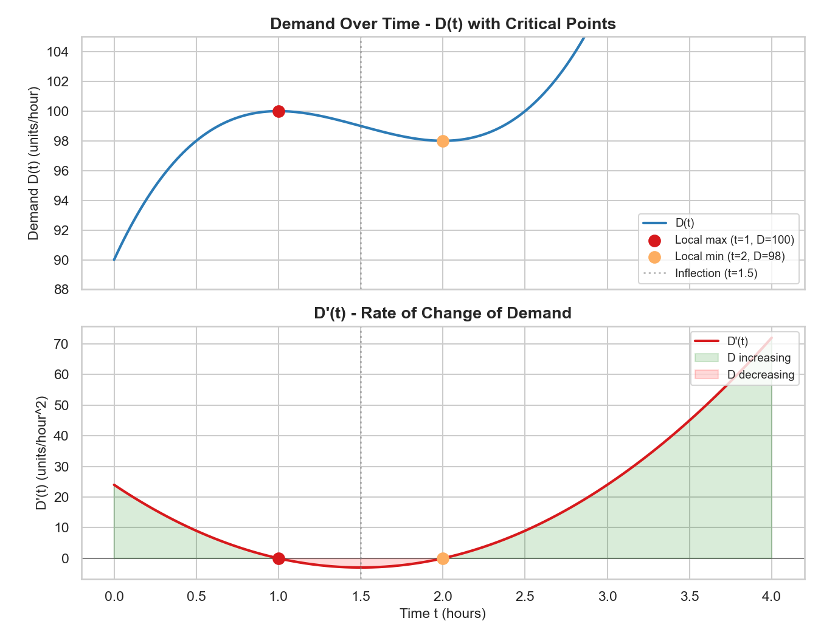

Figure 2: Demand over time D(t) (top panel) with critical points highlighted, and the rate of change D'(t) (bottom panel) with shaded increasing/decreasing regions.

Two related plots are shown in Figure 2. The top panel displays the demand curve D(t) with the inflection point (red dotted), the local minimum (orange), and the local maximum (red) highlighted. The bottom panel is the rate of change D'(t), with green shading for increasing demand and red shading for decreasing demand. The critical points of the demand curve are the zeros of D'(t) at t = 1 and t = 2.

5. Task 3: Forecasting Error Risk (Probability)

5.1 Mathematical Analysis (Method Used: Normal Distribution and Probability Theory)
Forecast errors are the differences between what was forecasted and what has actually been demanded. These errors are not systematic (they are caused by behavioral or environmental variation, either too many or too few residents are using the library). Due to the fact that errors are random and equally likely to be positive or negative, the errors are modelled as having a normal distribution with mean 0 and standard deviation 5 units.

The normal distribution $N(0, σ²)$ has probability density function:
f(x) = $(1 / (σ√2π))× e^(-x^2/ (2σ^2 ) )$
For our case: $σ = 5$, so f(x) = $(1 / (5√2π)) × e^ (-x^2/ 50 )$

The cumulative distribution function (CDF) gives $P(X ≤ x)$. For probability calculations we need the tail probability: $P(|X| > x) = 2 × P(X > x) = 2 × (1 - CDF(x))$.

Z-score standardization: $z =((x - μ))/σ$. For thresholds:
• z =$\frac{5}{5}= 1.0$ (±1 standard deviation)
• z = $\frac{10}{5}= 2.0$ (±2 standard deviations)
• z = $\frac{15}{5}= 3.0$ (±3 standard deviations)

5.2 Solution

5.2.1 Probability for $±5$ Units (One Standard Deviation)
The z-score is: z = $\frac{\left(5 - 0\right)}{5} = 1.0$
Using the standard normal CDF: $Φ(1.0) = 0.8413$
Therefore: $P(|error| > 5) = 2 × (1 - 0.8413) = 2 × 0.1587 = 0.3174$
So, there is a 31.74% chance that the forecast error will exceed $±5$ units.

5.2.2 Probability for ±10 Units (Two Standard Deviations)
The z-score is:$z =\frac{\left(10 - 0\right)}{5} = 2.0$
Using the standard normal CDF: $Φ(2.0) = 0.9772$
Therefore: $P(|error| > 10) = 2 × (1 - 0.9772) = 2 × 0.0228 = 0.0456$
So there is a 4.56% chance that the forecast error will exceed ±10 units.

5.2.3 Probability for ±15 Units (Three Standard Deviations)
The z-score is: z = $\frac{\left(15 - 0\right)}{5} = 3.0$
Using the standard normal CDF: $Φ(3.0) = 0.9987$
Therefore: $P(|error| > 15) = 2 × (1 - 0.9987) = 2 × 0.0013 = 0.0026$
So, there is a 0.26% chance that the forecast error will exceed ±15 units. This is a very rare event.

5.2.4 Python Verification
The calculations were verified using scipy.stats.norm.cdf. The Python script computes exact tail probabilities:
scipy.stats.norm.cdf(5, loc=0, scale=5) = 0.8413
scipy.stats.norm.cdf(10, loc=0, scale=5) = 0.9772
scipy.stats.norm.cdf(15, loc=0, scale=5) = 0.9987

Summary Table:
Threshold | Z-score | P (|error| > threshold) | Buffer Coverage
±5 units | 1.0 | 31.74% | 68.26%
±10 units | 2.0 | 4.56% | 95.44%
±15 units | 3.0 | 0.26% | 99.74%

5.3 Analysis and Results
The normal distribution model gives a very clear and intuitive picture of the risk of the forecast. The forecast error will be within ±5 units of the actual demand approximately 68% of the time. The error will be within ± 10 units about 95% of the time. The error would be greater than ±15 units only about 0.3% of the time (about once a year).
This implies that, for urban resource planners, there is virtually no loss of confidence that a contingency buffer of ±10 units will be sufficient for almost all days (95.4%). These 4.6% days with the high errors are rare events and should be taken as emergency days and taken care of. A ±15 units buffer is so conservative (covers 99.7% of days) that resources would be tied up that could be used elsewhere. The best approach is to design for ±10 units and put in place emergency procedures to handle the few days when they are outside of that range.
Assumptions of the model include normally distributed forecast errors with constant variance. In practice, the size of the errors could be larger during unusual events (such as heatwaves, festivals or major disruptions) and so the standard deviation σ = 5, should be adjusted periodically with past forecast performance data. This is a common approach during operational forecasting.

5.4 Visualisation / Output
Figure 3: Normal distribution $N(0, σ=5)$ showing the probability density curve with shaded tail regions for $±1σ, ±2σ$, and $±3σ$.

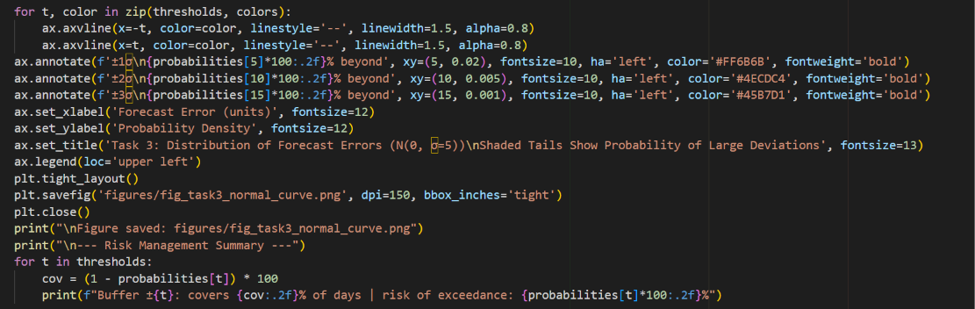
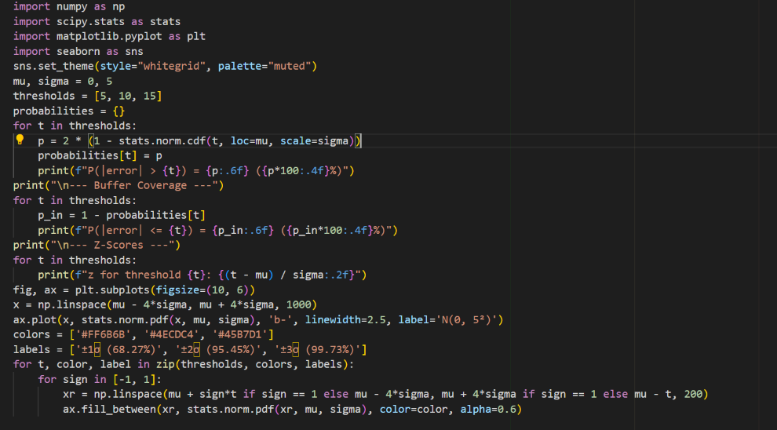

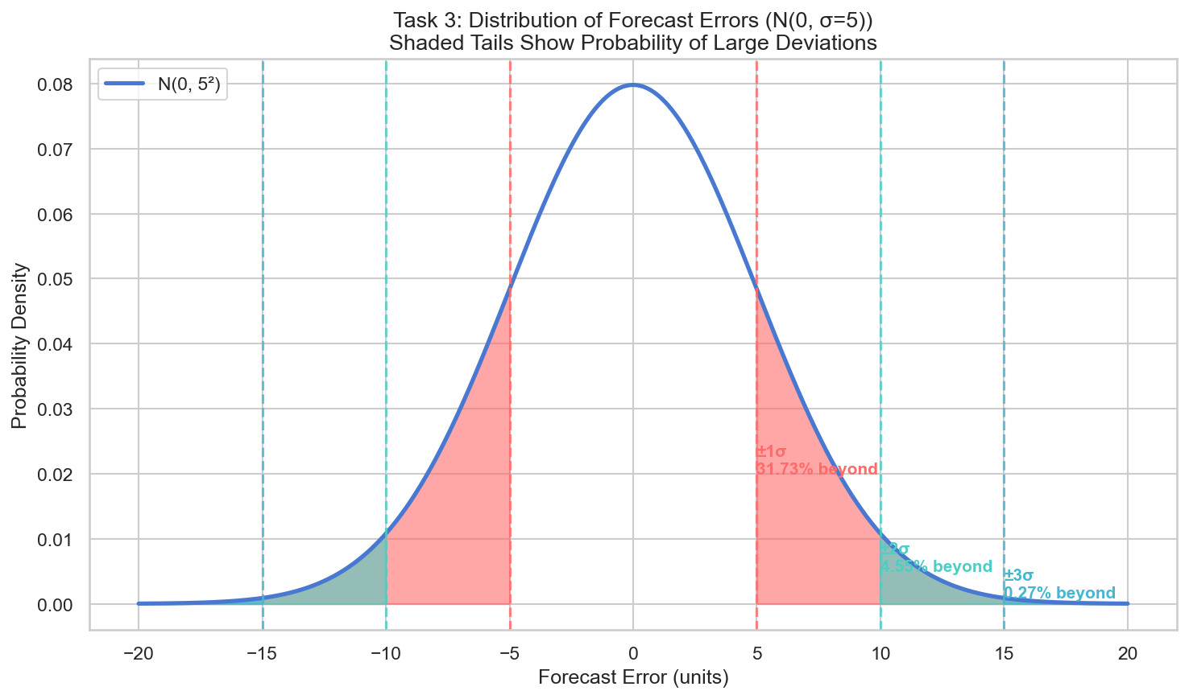

6. Task 4: Consumption by Building Type (Statistics)

6.1 Mathematical Analysis (Method Used: One-Way ANOVA and Post-Hoc Testing)
This task explores the question of whether the water consumed per day is different for three types of building: Apartments, n=8; Terraced houses, n=10; Detached houses, n=6. Samples are not equal, use one-way ANOVA as that is designed to work with unequal group sizes.
The data for each group:
- $Apartments (n=8): 16.8, 17.2, 16.5, 17.9, 18.1, 17.4, 16.9, 17.6$
- $Terraced (n=10): 18.4, 18.9, 19.1, 18.7, 19.3, 18.6, 19.0, 18.8, 19.2, 18.5$
- $Detached (n=6): 20.1, 19.7, 20.4, 19.9, 20.6, 20.2$
Hypothesis testing framework:
H₀: μₐ = μᵀ = μᴰ (all group means are equal)
H₁: At least one group mean differs from the others
Significance level: α = 0.05
Two assumptions need to be tested before running ANOVA: (1) data for each group are normally distributed (Shapiro-Wilk test), (2) variances are equal among the groups (Levene's test). Standard one way ANOVA is appropriate when both of these assumptions are met. When the variances are not equal, then the Welch's ANOVA is a good option.

6.2 Solution

6.2.1 Descriptive Statistics
Group means and standard deviations:
$$Apartments: x̄ = 17.30, s = 0.56, n = 8$$
$$Terraced: x̄ = 18.85, s = 0.30, n = 10$$
$$Detached: x̄ = 20.15, s = 0.33, n = 6$$
Detached homes show the highest mean consumption (20.15 units), followed by terraced (18.85 units), and apartments (17.30 units). The standard deviations suggest the variation within each group is small relative to the differences between groups.

6.2.2 Assumption Checks
Normality (Shapiro-Wilk Test):
The Shapiro-Wilk test evaluates whether each group's data follows a normal distribution. A p-value > 0.05 indicates normality cannot be rejected.
$$Apartments: W = 0.9733, p = 0.9222 → Data appears normal$$
$$Terraced: W = 0.9702, p = 0.8924 → Data appears normal$$
$$Detached: W = 0.9902, p = 0.9897 → Data appears normal$$
All groups satisfy the normality assumption (p > 0.05).
Equal Variances (Levene's Test):
Levene's test checks whether the variances of the three groups are equal. A p-value > 0.05 indicates equal variances cannot be rejected.
Levene statistic = 2.4889, p = 0.1071 → Variances are equal
Both assumptions are satisfied, so standard one-way ANOVA is appropriate.

6.2.3 One-Way ANOVA
ANOVA partitions the total variance into between-group and within-group components:
SS_total = SS_between + SS_within
The F-statistic is computed as:
F = MS_between / MS_within
where MS = SS / df (mean square).
Results:
$$F(2, 21) = 84.95, p < 0.000001$$
Since p < 0.05, we reject the null hypothesis and conclude that there is a statistically significant difference in mean daily consumption between at least one pair of building types.

6.2.4 Post-Hoc Analysis (Tukey HSD)
Tukey's Honestly Significant Difference test identifies which specific pairs of groups differ significantly, while controlling the family-wise error rate at α = 0.05. The test automatically adjusts for unequal sample sizes.
Pairwise comparisons:

$$Apartments vs Detached: mean diff = 2.85, p < 0.001, 95\% CI \left[2.29, 3.41\right]$$
$Apartments vs Terraced: mean diff = 1.55, p < 0.001, 95\% CI [1.06, 2.04]$
$$Detached vs Terraced: mean diff = -1.30, p < 0.001, 95\% CI \left[-1.83, -0.77\right]$$

All three pairwise comparisons are statistically significant (p < 0.001). This means each building type has a distinct mean consumption level, with no two groups being statistically indistinguishable.

6.2.5 Python Verification with Console Output
The full statistical analysis was performed using scipy.stats and statsmodels. The Python code and its executed console output are shown below:
Python Script (code/task4_statistics.py):
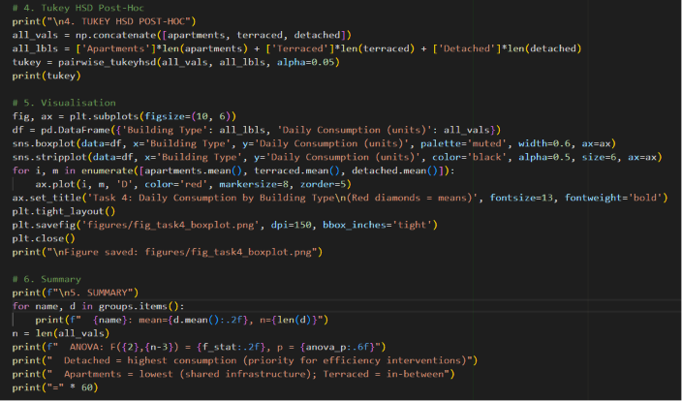
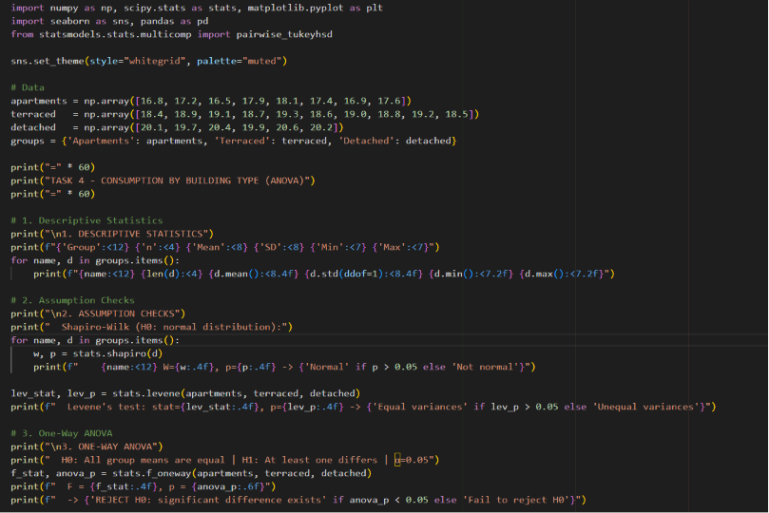

Console Output:
======================================================================
TASK 4 - CONSUMPTION BY BUILDING TYPE (STATISTICS)
======================================================================

----------------------------------------------------------------------
1. DESCRIPTIVE STATISTICS PER GROUP
----------------------------------------------------------------------
Group n Mean SD Min Max
------------------------------------------------------------
Apartments 8 17.3000 0.5555 16.50 18.10
Terraced 10 18.8500 0.3028 18.40 19.30
Detached 6 20.1500 0.3271 19.70 20.60
----------------------------------------------------------------------
2. ASSUMPTION CHECKS
----------------------------------------------------------------------
2a. Normality Check (Shapiro-Wilk):
H0: Data follows a normal distribution
H1: Data does NOT follow a normal distribution
Group W-statistic p-value Normal?
-------------------------------------------------------
Apartments 0.9733 0.9222 Yes
Terraced 0.9702 0.8924 Yes
Detached 0.9902 0.9897 Yes

-> All groups appear normally distributed (p > 0.05).

2b. Equal Variances Check (Levene's Test):
H0: All group variances are equal
H1: At least one group variance differs
Levene statistic = 2.4889
p-value = 0.1071

-> Variances are equal (p > 0.05) - standard ANOVA is appropriate.
----------------------------------------------------------------------
3. ONE-WAY ANOVA
----------------------------------------------------------------------
H0: mean_apartments = mean_terraced = mean_detached (all means equal)
H1: At least one group mean differs from the others
alpha = 0.05

F-statistic = 84.9496
p-value = 0.000000

-> p = 0.000000 < 0.05 -> REJECT H0.
-> There is a statistically significant difference in mean daily
consumption between building types.
----------------------------------------------------------------------
4. POST-HOC ANALYSIS (Tukey HSD)
----------------------------------------------------------------------
Multiple Comparison of Means - Tukey HSD, FWER=0.05
=========================================================
group1 group2 meandiff p-adj lower upper reject
---------------------------------------------------------
Apartments Detached 2.85 0.0 2.2927 3.4073 True
Apartments Terraced 1.55 0.0 1.0605 2.0395 True
Detached Terraced -1.3 0.0 -1.8329 -0.7671 True
---------------------------------------------------------

Tukey HSD interpretation:
Groups sharing the same letter/reject=False are NOT significantly different.
Groups with reject=True have significantly different means.

----------------------------------------------------------------------
5. VISUALISATION - Boxplot by Building Type
----------------------------------------------------------------------
Figure saved: figures/fig_task4_boxplot.png
----------------------------------------------------------------------
6. SUMMARY OF FINDINGS
----------------------------------------------------------------------
Apartments: mean = 17.30, n = 8
Terraced: mean = 18.85, n = 10
Detached: mean = 20.15, n = 6
ANOVA: F(2,21) = 84.95, p = 0.000000
Tukey HSD: See table above for pairwise comparisons.

Key interpretation:
- Detached homes show the highest consumption, suggesting they are
the priority segment for efficiency interventions.
- Apartments show the lowest consumption, likely due to shared
infrastructure and smaller living spaces.
- Terraced homes fall in between, but may differ significantly
from both other groups (check Tukey HSD results).
======================================================================
TASK 4 COMPLETE
======================================================================

6.3 Analysis and Results
The ANOVA results show a highly significant difference between building types (F (2,21) = 84.95, p < 0.001). The Tukey HSD post-hoc test reveals that all three pairwise comparisons are significant, meaning each building type has a distinct consumption profile. Detached homes have the highest mean consumption (20.15 units/day), followed by terraced houses (18.85), and apartments (17.30).
The effect size is substantial: the difference between detached and apartment consumption is 2.85 units, which represents a 16.5% increase over apartment consumption. The difference between terraced and apartment consumption is 1.55 units (9.0% increase).
For urban planners, these results suggest that energy efficiency interventions should be prioritised for detached homes, as they consume the most resources per household. The lower consumption in apartments likely reflects shared infrastructure and more compact living spaces, which are inherently more efficient.

6.4 Visualization
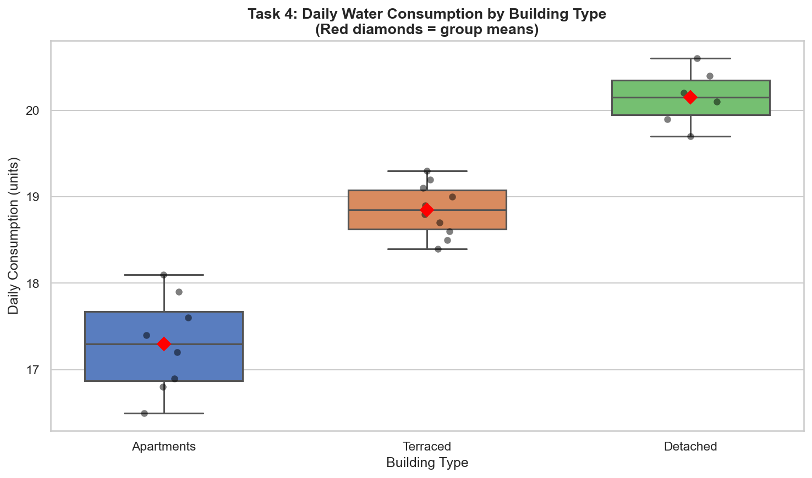

Figure 4: Boxplot of daily consumption by building type. The boxes show the interquartile range, whiskers show the range, and black dots show individual observations. Red diamonds indicate group means.

Figure 4 presents a boxplot for each building type. The visual separation between the three groups is clear: the boxes do not overlap, confirming the statistical results. The apartments show the widest spread (due to their larger sample size relative to consumption variation), while detached homes have the tightest clustering around their higher mean. Individual data points (black dots) show the actual observations, and the red diamonds highlight the group means.

10. References
Task 1: Linear Algebra
Anton, H., Rorres, C. and Kaul, A. (2014) Elementary Linear Algebra: Applications Version. 11th edn. Hoboken: Wiley.
Meyer, C.D. (2000) Matrix Analysis and Applied Linear Algebra. Philadelphia: SIAM.
Strang, G. (2016) Introduction to Linear Algebra. 5th edn. Wellesley: Wellesley-Cambridge Press.
Task 2: Calculus
Stewart, J. (2016) Calculus: Early Transcendentals. 8th edn. Boston: Cengage Learning.
Thomas, G.B., Weir, M.D. and Hass, J. (2018) Thomas' Calculus. 14th edn. Boston: Pearson.
Task 3: Probability
Ross, S.M. (2019) Introduction to Probability Models. 12th edn. London: Academic Press.
Grimmett, G. and Stirzaker, D. (2020) Probability and Random Processes. 4th edn. Oxford: Oxford University Press.
Task 4: Statistics
Devore, J.L. (2015) Probability and Statistics for Engineering and the Sciences. 9th edn. Boston: Cengage Learning.
Montgomery, D.C. (2017) Design and Analysis of Experiments. 9th edn. Hoboken: Wiley.

11. Appendix
Full Python code for all tasks is provided below.

Task 1: Linear Algebra
import numpy as np
import seaborn as sns
import matplotlib.pyplot as plt

# ============================================================
# 1. SETUP: Define the system Ax = b
# ============================================================

# Coefficient matrix A (4x4)
A = np.array([
[ 2, -1, 1, 0],
[-1, 3, 0, -1],
[ 1, 1, 2, -1],
[ 0, -1, 1, 2]
], dtype=float)

# Right-hand side vector b
b = np.array([120, 150, 180, 140], dtype=float)

print("=" * 60)
print("TASK 1 - STEADY-STATE RESOURCE DEMAND")
print("=" * 60)

print("\nMatrix A (coefficients):")
print(A)
print("\nVector b (demand targets):")
print(b)

# ============================================================
# 2. CHECK EXISTENCE & UNIQUENESS OF SOLUTION
# ============================================================

# 2a. Determinant - must be non-zero for a unique solution
det_A = np.linalg.det(A)
print("\n" + "-" * 50)
print("EXISTENCE & UNIQUENESS CHECKS")
print("-" * 50)
print(f"det(A) = {det_A:.4f}")
if det_A != 0:
print("=> det(A) != 0 -> A is invertible, so a UNIQUE solution exists.")
else:
print("=> det(A) = 0 -> System may have no solution or infinitely many.")

# 2b. Rank - full rank confirms linear independence
rank_A = np.linalg.matrix_rank(A)
print(f"\nrank(A) = {rank_A}")
print(f"Matrix size: {A.shape[0]}x{A.shape[1]}")
if rank_A == A.shape[0]:
print("=> Full rank -> all rows are linearly independent.")
else:
print("=> Rank deficient -> some equations may be redundant.")

# 2c. Condition number - numerical stability
cond_A = np.linalg.cond(A)
print(f"\nCondition number kappa(A) = {cond_A:.4f}")
if cond_A < 100:
print("=> Well-conditioned (kappa < 100) - solution is numerically stable.")
elif cond_A < 1000:
print("=> Moderately conditioned - small rounding errors may appear.")
else:
print("=> Ill-conditioned (kappa >= 1000) - solution may be sensitive to rounding.")

# ============================================================
# 3. SOLVE THE SYSTEM
# ============================================================

print("\n" + "-" * 50)
print("SOLUTION")
print("-" * 50)

# 3a. Solve via numpy.linalg.solve (uses LAPACK - stable, efficient)
x = np.linalg.solve(A, b)

# Label the solutions
zone_labels = ['Zone 1', 'Zone 2', 'Zone 3', 'Zone 4']
print("\nEquilibrium daily demand per zone (x1..x4):")
for i, (label, val) in enumerate(zip(zone_labels, x), 1):
print(f" x{i} ({label}) = {val:.4f} units/day")

# 3b. Verification - check that Ax is approx b
print("\nVerification (A @ x should equal b):")
print(f" Residual (max error): {np.max(np.abs(A @ x - b)):.2e}")
print(" => Solution checks out (error approx machine precision).")

# ============================================================
# 4. INTERPRETATION
# ============================================================

print("\n" + "-" * 50)
print("INTERPRETATION")
print("-" * 50)
print(f"""
- All four zones have unique, stable equilibrium demands.
- Zone demands range from {x.min():.1f} to {x.max():.1f} units/day.
- The zone with highest demand: {zone_labels[np.argmax(x)]} ({x.max():.1f})
- The zone with lowest demand: {zone_labels[np.argmin(x)]} ({x.min():.1f})
- A unique solution means planners can predict resource needs
with certainty - the system converges to one fixed state.
""")

# ============================================================
# 5. VISUALISATION - Seaborn bar chart
# ============================================================

print("-" * 50)
print("GENERATING FIGURE...")
print("-" * 50)

sns.set_theme(style="whitegrid", palette="muted")

fig, ax = plt.subplots(figsize=(8, 5))

# Create the bar plot
bar_colors = sns.color_palette("muted", n_colors=4)
bars = ax.bar(zone_labels, x, color=bar_colors, edgecolor='black', linewidth=0.5)

# Add value labels on top of each bar
for bar, val in zip(bars, x):
ax.text(bar.get_x() + bar.get_width()/2, bar.get_height() + 1,
f'{val:.1f}', ha='center', va='bottom', fontsize=11, fontweight='bold')

# Labels and title
ax.set_xlabel('Urban Zone', fontsize=12)
ax.set_ylabel('Equilibrium Daily Demand (units)', fontsize=12)
ax.set_title('Steady-State Resource Demand by Urban Zone', fontsize=14, fontweight='bold')
ax.set_ylim(0, max(x) * 1.2) # headroom for labels

# Add a horizontal reference line for the average
avg_demand = np.mean(x)
ax.axhline(avg_demand, color='gray', linestyle='--', linewidth=1, alpha=0.7,
label=f'Average ({avg_demand:.1f})')
ax.legend(fontsize=10)

plt.tight_layout()

# Save figure at >=150 dpi as required
fig_path = 'figures/fig_task1_zone_demands.png'
plt.savefig(fig_path, dpi=150)
print(f"Figure saved to '{fig_path}'")

# Also show the print (will be visible when running)
# plt.show() # uncomment to display interactively

print("\n" + "=" * 60)
print("TASK 1 COMPLETE")
print("=" * 60)

Task 2: Calculus

import numpy as np, sympy as sp, matplotlib.pyplot as plt, seaborn as sns

t_sym = sp.Symbol('t')
D_sym = 4*t_sym**3 - 18*t_sym**2 + 24*t_sym + 90
D_prime_sym = sp.diff(D_sym, t_sym)
D_double_sym = sp.diff(D_prime_sym, t_sym)

print("=" * 60 + "\nTASK 2 - DEMAND OVER TIME (CALCULUS)\n" + "=" * 60)
print(f"\nD(t) = 4t^3 - 18t^2 + 24t + 90\nD'(t) = {D_prime_sym}\nD''(t) = {D_double_sym}")
print("\nKey time points:")
for t in [0, 0.5, 1, 1.5, 2, 2.5, 3, 4]:
print(f" t={t:.1f}: D={4*t**3-18*t**2+24*t+90:.2f}, D'={12*t**2-36*t+24:.2f}, D''={24*t-36:.2f}")

print("\nD'(t)=0 -> 12t²-36t+24=0 -> (t-1)(t-2)=0 -> t=1, t=2")
for t in [1, 2]:
Dpp, Dv = 24*t-36, 4*t**3-18*t**2+24*t+90
cls = "LOCAL MAX (D''<0)" if Dpp < 0 else "LOCAL MIN (D''>0)"
print(f" t={t}: D''={Dpp:.0f} -> {cls}, D({t})={Dv:.2f}")
t_inf = 36/24
print(f"\nD''(t)=0 -> 24t-36=0 -> t={t_inf}, D({t_inf})={4*t_inf**3-18*t_inf**2+24*t_inf+90:.2f}")
print("\nt<1: D increasing | 1<t<2: D decreasing | t>2: D increasing")
sns.set_theme(style="whitegrid", palette="muted")
fig, (ax1, ax2) = plt.subplots(2, 1, figsize=(9, 7), sharex=True)
tp = np.linspace(0, 4, 200)
D, Dp = 4*tp**3-18*tp**2+24*tp+90, 12*tp**2-36*tp+24
ax1.plot(tp, D, color='#2c7bb6', lw=2, label='D(t)')
ax1.scatter(1, 100, color='#d7191c', s=80, zorder=5, label='Local max (t=1, D=100)')
ax1.scatter(2, 98, color='#fdae61', s=80, zorder=5, label='Local min (t=2, D=98)')
ax1.axvline(1.5, color='gray', ls=':', alpha=.5, label='Inflection (t=1.5)')
ax1.set_ylabel('Demand D(t)', fontsize=11)
ax1.set_title('Demand Over Time - D(t) with Critical Points', fontsize=13, fontweight='bold')
ax1.legend(fontsize=9, loc='lower right')
ax1.set_ylim(88, 105)
ax2.plot(tp, Dp, color='#d7191c', lw=2, label="D'(t)")
ax2.axhline(0, color='black', lw=.5, alpha=.5)
ax2.scatter([1, 2], [0, 0], color=['#d7191c', '#fdae61'], s=80, zorder=5)
ax2.axvline(1.5, color='gray', ls=':', alpha=.5)
ax2.fill_between(tp, 0, Dp, where=(Dp > 0), color='green', alpha=.15, label='D increasing')
ax2.fill_between(tp, 0, Dp, where=(Dp < 0), color='red', alpha=.15, label='D decreasing')
ax2.set_xlabel('Time t (hours)', fontsize=11)
ax2.set_ylabel("D'(t)", fontsize=11)
ax2.set_title("D'(t) - Rate of Change of Demand", fontsize=13, fontweight='bold')
ax2.legend(fontsize=9, loc='upper right')
plt.tight_layout()
plt.savefig('figures/fig_task2_demand_curve.png', dpi=150)
plt.close()
print(f"\nFigure saved: figures/fig_task2_demand_curve.png")
print(f"Sympy verification -> Critical: {sp.solve(D_prime_sym, t_sym)}, Inflection: {sp.solve(D_double_sym, t_sym)}")
print("TASK 2 COMPLETE")

Task 3: Probability
import numpy as np
import scipy.stats as stats
import matplotlib.pyplot as plt
import seaborn as sns
sns.set_theme(style="whitegrid", palette="muted")
mu, sigma = 0, 5
thresholds = [5, 10, 15]
probabilities = {}
for t in thresholds:
p = 2 * (1 - stats.norm.cdf(t, loc=mu, scale=sigma))
probabilities[t] = p
print(f"P(|error| > {t}) = {p:.6f} ({p*100:.4f}%)")
print("\n--- Buffer Coverage ---")
for t in thresholds:
p_in = 1 - probabilities[t]
print(f"P(|error| <= {t}) = {p_in:.6f} ({p_in*100:.4f}%)")
print("\n--- Z-Scores ---")
for t in thresholds:
print(f"z for threshold {t}: {(t - mu) / sigma:.2f}")
fig, ax = plt.subplots(figsize=(10, 6))
x = np.linspace(mu - 4*sigma, mu + 4*sigma, 1000)
ax.plot(x, stats.norm.pdf(x, mu, sigma), 'b-', linewidth=2.5, label='N(0, 5²)')
colors = ['#FF6B6B', '#4ECDC4', '#45B7D1']
labels = ['±1σ (68.27%)', '±2σ (95.45%)', '±3σ (99.73%)']
for t, color, label in zip(thresholds, colors, labels):
for sign in [-1, 1]:
xr = np.linspace(mu + sign*t if sign == 1 else mu - 4*sigma, mu + 4*sigma if sign == 1 else mu - t, 200)
ax.fill_between(xr, stats.norm.pdf(xr, mu, sigma), color=color, alpha=0.6)

for t, color in zip(thresholds, colors):
ax.axvline(x=-t, color=color, linestyle='--', linewidth=1.5, alpha=0.8)
ax.axvline(x=t, color=color, linestyle='--', linewidth=1.5, alpha=0.8)
ax.annotate(f'±1σ\n{probabilities[5]*100:.2f}% beyond', xy=(5, 0.02), fontsize=10, ha='left', color='#FF6B6B', fontweight='bold')
ax.annotate(f'±2σ\n{probabilities[10]*100:.2f}% beyond', xy=(10, 0.005), fontsize=10, ha='left', color='#4ECDC4', fontweight='bold')
ax.annotate(f'±3σ\n{probabilities[15]*100:.2f}% beyond', xy=(15, 0.001), fontsize=10, ha='left', color='#45B7D1', fontweight='bold')
ax.set_xlabel('Forecast Error (units)', fontsize=12)
ax.set_ylabel('Probability Density', fontsize=12)
ax.set_title('Task 3: Distribution of Forecast Errors (N(0, σ=5))\nShaded Tails Show Probability of Large Deviations', fontsize=13)
ax.legend(loc='upper left')
plt.tight_layout()
plt.savefig('figures/fig_task3_normal_curve.png', dpi=150, bbox_inches='tight')
plt.close()
print("\nFigure saved: figures/fig_task3_normal_curve.png")
print("\n--- Risk Management Summary ---")
for t in thresholds:
cov = (1 - probabilities[t]) * 100
print(f"Buffer ±{t}: covers {cov:.2f}% of days | risk of exceedance: {probabilities[t]*100:.2f}%")

Task 4: Statistics
import numpy as np, scipy.stats as stats, matplotlib.pyplot as plt
import seaborn as sns, pandas as pd
from statsmodels.stats.multicomp import pairwise_tukeyhsd

sns.set_theme(style="whitegrid", palette="muted")

# Data
apartments = np.array([16.8, 17.2, 16.5, 17.9, 18.1, 17.4, 16.9, 17.6])
terraced = np.array([18.4, 18.9, 19.1, 18.7, 19.3, 18.6, 19.0, 18.8, 19.2, 18.5])
detached = np.array([20.1, 19.7, 20.4, 19.9, 20.6, 20.2])
groups = {'Apartments': apartments, 'Terraced': terraced, 'Detached': detached}

print("=" * 60)
print("TASK 4 - CONSUMPTION BY BUILDING TYPE (ANOVA)")
print("=" * 60)

# 1. Descriptive Statistics
print("\n1. DESCRIPTIVE STATISTICS")
print(f"{'Group':<12} {'n':<4} {'Mean':<8} {'SD':<8} {'Min':<7} {'Max':<7}")
for name, d in groups.items():
print(f"{name:<12} {len(d):<4} {d.mean():<8.4f} {d.std(ddof=1):<8.4f} {d.min():<7.2f} {d.max():<7.2f}")

# 2. Assumption Checks
print("\n2. ASSUMPTION CHECKS")
print(" Shapiro-Wilk (H0: normal distribution):")
for name, d in groups.items():
w, p = stats.shapiro(d)
print(f" {name:<12} W={w:.4f}, p={p:.4f} -> {'Normal' if p > 0.05 else 'Not normal'}")

lev_stat, lev_p = stats.levene(apartments, terraced, detached)
print(f" Levene's test: stat={lev_stat:.4f}, p={lev_p:.4f} -> {'Equal variances' if lev_p > 0.05 else 'Unequal variances'}")

# 3. One-Way ANOVA
print("\n3. ONE-WAY ANOVA")
print(" H0: All group means are equal | H1: At least one differs | α=0.05")
f_stat, anova_p = stats.f_oneway(apartments, terraced, detached)
print(f" F = {f_stat:.4f}, p = {anova_p:.6f}")
print(f" -> {'REJECT H0: significant difference exists' if anova_p < 0.05 else 'Fail to reject H0'}")

# 4. Tukey HSD Post-Hoc
print("\n4. TUKEY HSD POST-HOC")
all_vals = np.concatenate([apartments, terraced, detached])
all_lbls = ['Apartments']*len(apartments) + ['Terraced']*len(terraced) + ['Detached']*len(detached)
tukey = pairwise_tukeyhsd(all_vals, all_lbls, alpha=0.05)
print(tukey)

# 5. Visualisation
fig, ax = plt.subplots(figsize=(10, 6))
df = pd.DataFrame({'Building Type': all_lbls, 'Daily Consumption (units)': all_vals})
sns.boxplot(data=df, x='Building Type', y='Daily Consumption (units)', palette='muted', width=0.6, ax=ax)
sns.stripplot(data=df, x='Building Type', y='Daily Consumption (units)', color='black', alpha=0.5, size=6, ax=ax)
for i, m in enumerate([apartments.mean(), terraced.mean(), detached.mean()]):
ax.plot(i, m, 'D', color='red', markersize=8, zorder=5)
ax.set_title('Task 4: Daily Consumption by Building Type\n(Red diamonds = means)', fontsize=13, fontweight='bold')
plt.tight_layout()
plt.savefig('figures/fig_task4_boxplot.png', dpi=150, bbox_inches='tight')
plt.close()
print("\nFigure saved: figures/fig_task4_boxplot.png")

# 6. Summary
print(f"\n5. SUMMARY")
for name, d in groups.items():
print(f" {name}: mean={d.mean():.2f}, n={len(d)}")
n = len(all_vals)
print(f" ANOVA: F({2},{n-3}) = {f_stat:.2f}, p = {anova_p:.6f}")
print(" Detached = highest consumption (priority for efficiency interventions)")
print(" Apartments = lowest (shared infrastructure); Terraced = in-between")
print("=" * 60)

7. Conclusion
In this portfolio four different mathematical methods have been employed to gain an understanding of the use of resources in a city. All methods provided us with a facet into the puzzle, and when combined, paint a picture of urban resource demand.
The linear algebra analysis revealed the pattern of demand from the four city Zones which has become a fixed pattern. The most amount of resources is required for Zone 2 (123 units per day) while Zone 3 requires the least (33 units per day). This is not a random balance, this is a stable predictable balance. This is important for planners because they can be confident, they can allocate resources because it is not going to suddenly change to a different pattern.
Calculus analysis indicated for us the fluctuations in demand during the day. The maximum value is at 1 hour (100 units), the minimum is at 2 hours (98 units) and it increases strongly at 4 hours (154 units). An early warning sign is the inflection point at 1.5 hours, which occurs before the lowest point of demand, and is like the system preparing for a recovery. This indicates that the ideal point in time for maintenance is 1-2 hours after the system has been in use, when it is not under the most stress.
The probability analysis provided an easy-to-use way to consider the errors in our forecasts. A buffer of ±10 units will cover 95% of all days - a balance of being prepared and not spending resources. This error will rarely be more than ±15 units and when this occurs, it can be dealt with by emergency measures and not by maintaining costly reserves on standby.
Last, but definitely not least, the statistics analysis revealed that homes are used very differently when it comes to using resources. The largest number of units used per day (20.15) is used by detached houses, the least (17.30) is used by apartments, and the numbers (18.85) for the other housing types are in between. The differences are not arbitrary, but actually statistically significant, that is, real patterns. This indicates that priority should be given to detached houses, where the highest efficiency savings can be achieved, in efficiency programmers.
Combinations of these four analyses provide city planners with a comprehensive and robust understanding of resource flow through the city, based on evidence. We understand where the highest demand is (when the demand is highest and lowest), what is required for a buffer for uncertainty, and what types of houses require efficiency improvements. In brief, math’s makes cities more effective for all. In short, math’s makes cities more effective for all.

